Subject | English
Student’s Book | Aspect for Kazakhstan. Grammar schools. Student’s Book by Jenny Dooley-Bob Obee. Express Publishing
Teacher
Grade | 10 (Social and humanities studies strand)
Module 1 | Legend or Truth?
Lesson 1 (c ) | 4
Theme | Use of English. Past tenses
Learning objectives | - to learn or revise the past simple, the past continuous, the past perfect and the past perfect continuous;  - to compare the past simple and the present perfect, to compare the present perfect and the present perfect continuous.
Steps | Procedure | Resources
Step 1.  Grammar revision. | Task 1. Grammar revision.  Past Simple, Past Continuous and Past Perfect tenses. | slides 2-4
Step 2.  Presentation the Past Perfect Continuous | Task 2. Presentation the Past Perfect Continuous  had been +V ing  - Подчеркивается длительность действия, которое началось и закончилось в прошлом перед другим действием в прошлом обычно с since или for,how long  - Действие, которое началось и закончилось в прошлом и косвенные результаты (побочное следствие) которого были очевидны.  Words  before, since, for, how long, till/until  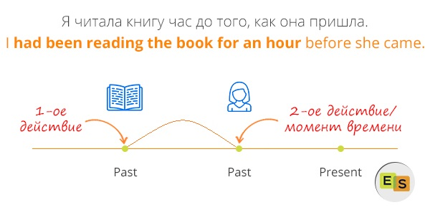  eg. She had been cooking a lemon pie for an hour before I came. – Она готовила лимонный пирог в течение часа перед тем, как я пришел.  eg. There were puddles in the street. It had been raining at night. – На улицах были лужи. Ночью шел дождь. (Мы не застали момент, когда дождь шел, но мы видели результат – лужи) | slides 5-7
Step 3.  Practice | Task 3. Read the text. Identify the tenses.  Then match the verbs in bold (1-7) to their uses (A-G).  Task 4. Practice the past tenses.  Choose the correct item.  They went/had gone shopping and bought/  had bought a tent for their hiking trip.  2 She read/has read the book a few years ago  3 They drove/were driving to the house when  the car broke/was breaking down  4 When did you start/have you started rock  climbing?  5 They realised/were realising that they were losing/had lost their way so they stopped/ had stopped to get directions | SB p.10 ex.1  slide 8  slide 9  SB ex.4 p.10
Reflection | Now I can……  Now I know ……  Well, thanks a lot. I’m satisfied with your work. What have you learned today? Did you like the lesson?

